Original Brain Stroke Patient Data
Exploratory Analysis and Visualization Report
Includes data-quality checks, descriptive summaries, embedded plots, and a standalone interactive dashboard.

1. Executive Summary
The uploaded original brain stroke patient dataset was loaded, checked for structural data quality, summarized, and visualized. The dataset contains a rare stroke outcome, with approximately 5.0% of patients labeled as stroke cases. Exploratory patterns show the strongest observed differences by age, medical history indicators, average glucose level, BMI, and smoking status. These are descriptive associations only and should not be interpreted as causal effects.
Item | Result
Original file | a7c99cd2-c13c-4bab-8187-c32a6ae2efcc.xlsx
Worksheet analyzed | full_data_real
Records | 4,981
Original columns | 11
Stroke cases | 248
No-stroke cases | 4,733
Stroke prevalence | 4.98%
Missing values | 0
Duplicate rows | 0

2. Data Structure and Quality Checks
The dataset had 11 original columns. No missing values and no duplicate rows were detected. The target variable is stroke, coded as 0 = No Stroke and 1 = Stroke.
Table 1. Column names and data types
Column | Data type
Gender | object
age | float64
hypertension | int64
heart_disease | int64
ever_married | object
work_type | object
Residence_type | object
avg_glucose_level | float64
bmi | float64
smoking_status | object
stroke | int64
Table 2. Missing-value summary
Column | missing_count | missing_pct
Gender | 0 | 0.00%
age | 0 | 0.00%
hypertension | 0 | 0.00%
heart_disease | 0 | 0.00%
ever_married | 0 | 0.00%
work_type | 0 | 0.00%
Residence_type | 0 | 0.00%
avg_glucose_level | 0 | 0.00%
bmi | 0 | 0.00%
smoking_status | 0 | 0.00%
stroke | 0 | 0.00%

3. Target Variable Distribution
Table 3. Stroke target distribution
Stroke class | Meaning | Count | Percentage
0 | No Stroke | 4733 | 95.02%
1 | Stroke | 248 | 4.98%
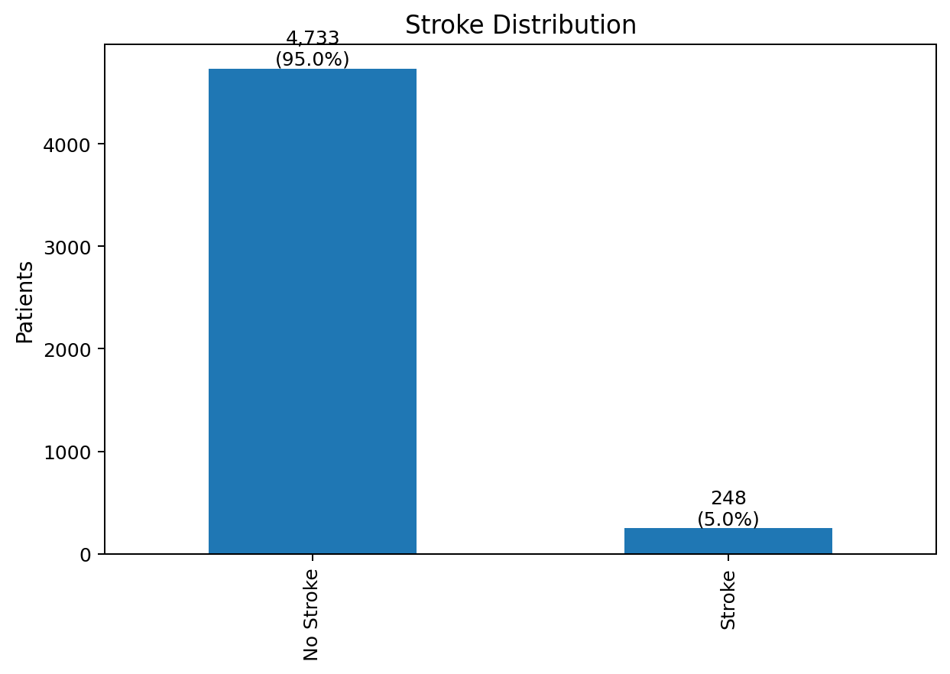
Figure 1. Stroke distribution in the original dataset.

4. Numerical Descriptive Summary
Stroke patients were older on average (67.8 years) than non-stroke patients (42.1 years). They also had higher average glucose (132.2 vs 104.6) and higher average BMI (30.2 vs 28.4).
Table 4. Key numerical averages by stroke status
Metric | No Stroke | Stroke
Average age | 42.14 | 67.82
Average glucose level | 104.57 | 132.18
Average BMI | 28.41 | 30.19
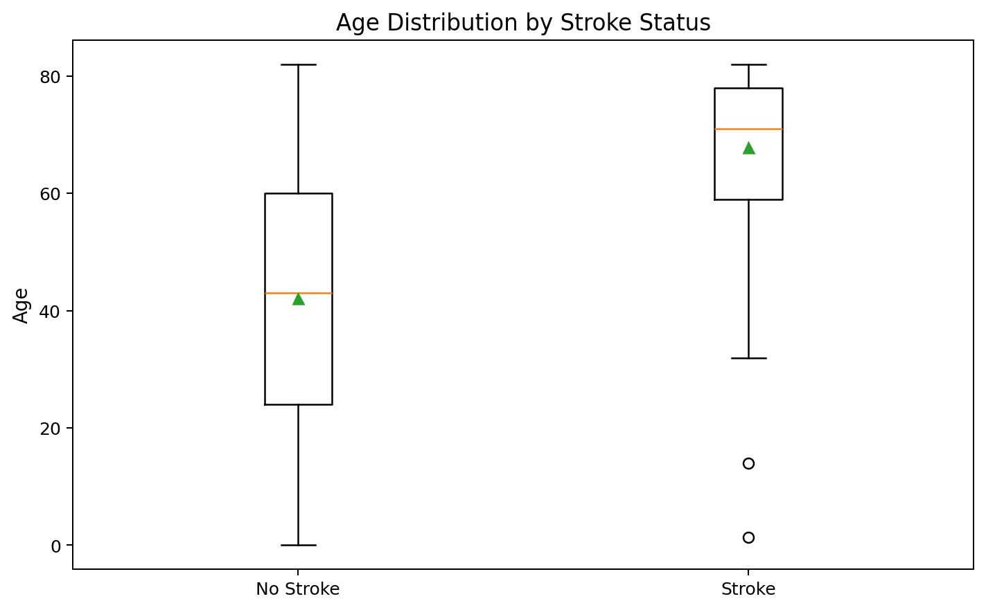
Figure 2. Age distribution by stroke status.
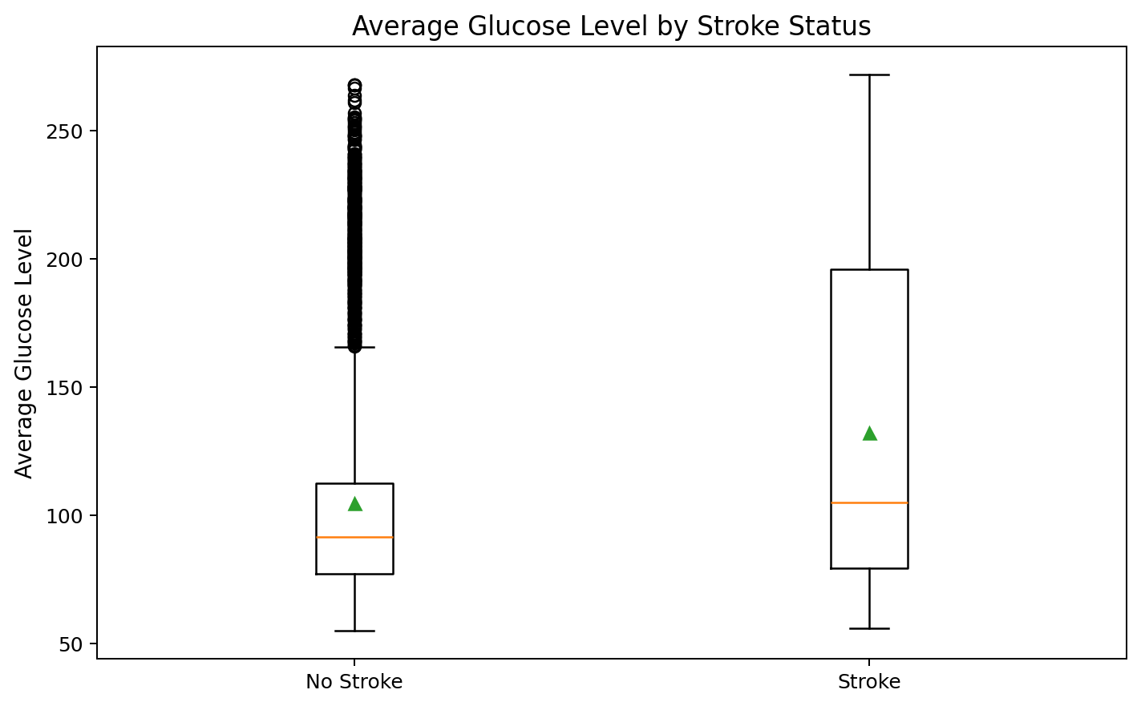
Figure 3. Average glucose level by stroke status.
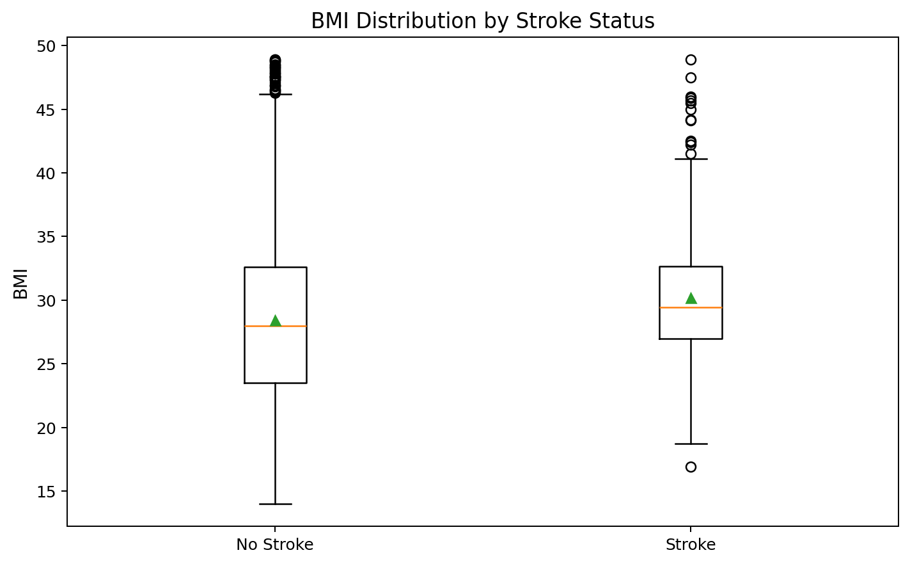
Figure 4. BMI distribution by stroke status.

5. Stroke Rates by Patient Characteristics
Stroke rates were summarized across clinically relevant groupings. The highest observed rate was among seniors aged 66+, followed by patients with heart disease, patients with hypertension, and patients with glucose level 126+.
Table 5. Stroke rate by age group
Age group | Patients | Stroke cases | Stroke rate (%)
Child (0-12) | 574 | 1 | 0.2%
Teen (13-18) | 306 | 1 | 0.3%
Young adult (19-35) | 961 | 1 | 0.1%
Adult (36-50) | 1047 | 19 | 1.8%
Older adult (51-65) | 1134 | 70 | 6.2%
Senior (66+) | 959 | 156 | 16.3%
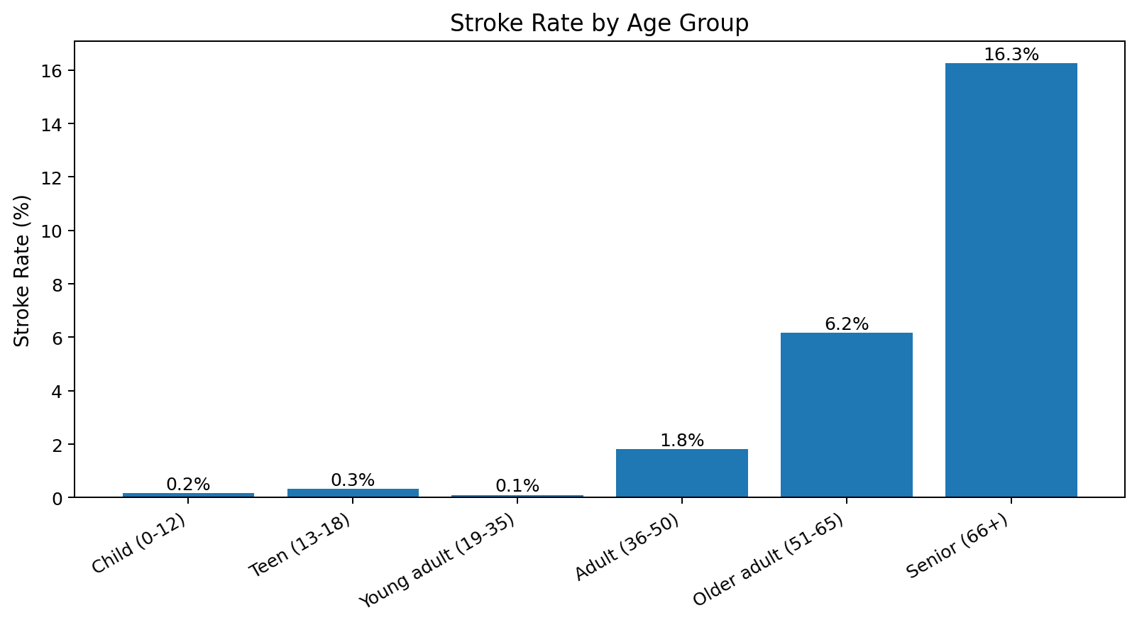
Figure 5. Stroke rate by age group.
Table 6. Stroke rate by medical risk factor
Risk factor | Stroke rate (%)
Hypertension | 13.8%
No hypertension | 4.0%
Heart disease | 17.1%
No heart disease | 4.3%
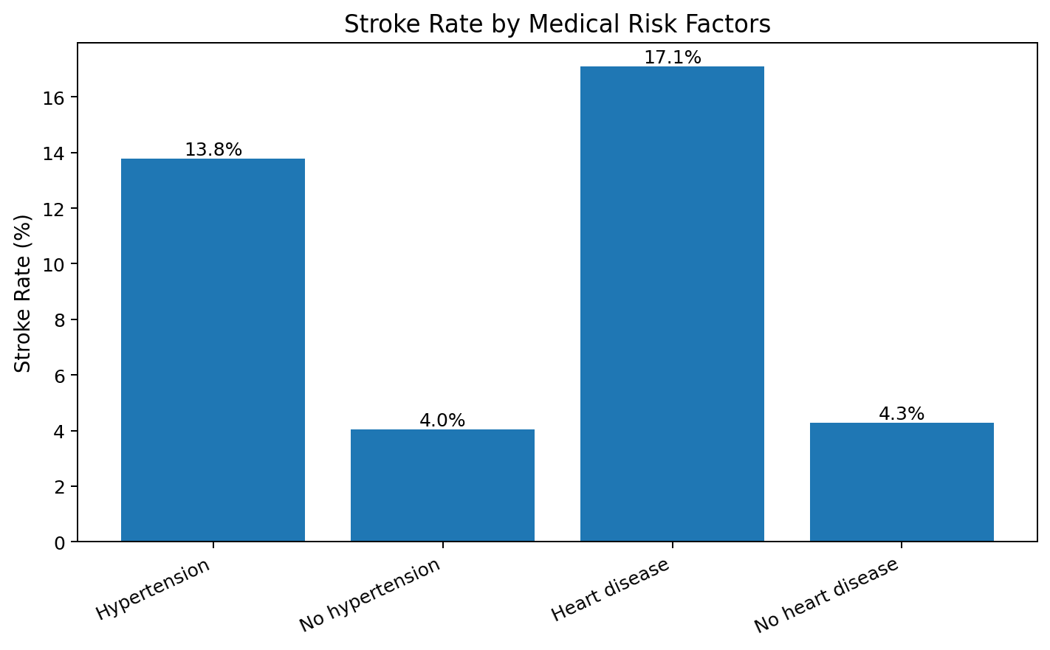
Figure 6. Stroke rate by medical risk factors.
Table 7. Stroke rate by smoking status
Smoking status | Patients | Stroke cases | Stroke rate (%)
formerly smoked | 867 | 70 | 8.1%
smokes | 776 | 42 | 5.4%
never smoked | 1838 | 89 | 4.8%
Unknown | 1500 | 47 | 3.1%
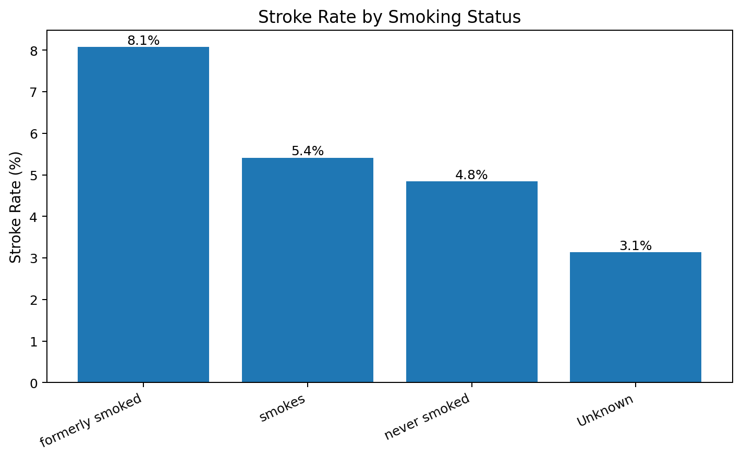
Figure 7. Stroke rate by smoking status.
Table 8. Stroke rate by glucose category
Glucose category | Patients | Stroke cases | Stroke rate (%)
<100 | 3061 | 112 | 3.7%
100-125 | 973 | 37 | 3.8%
126+ | 947 | 99 | 10.5%
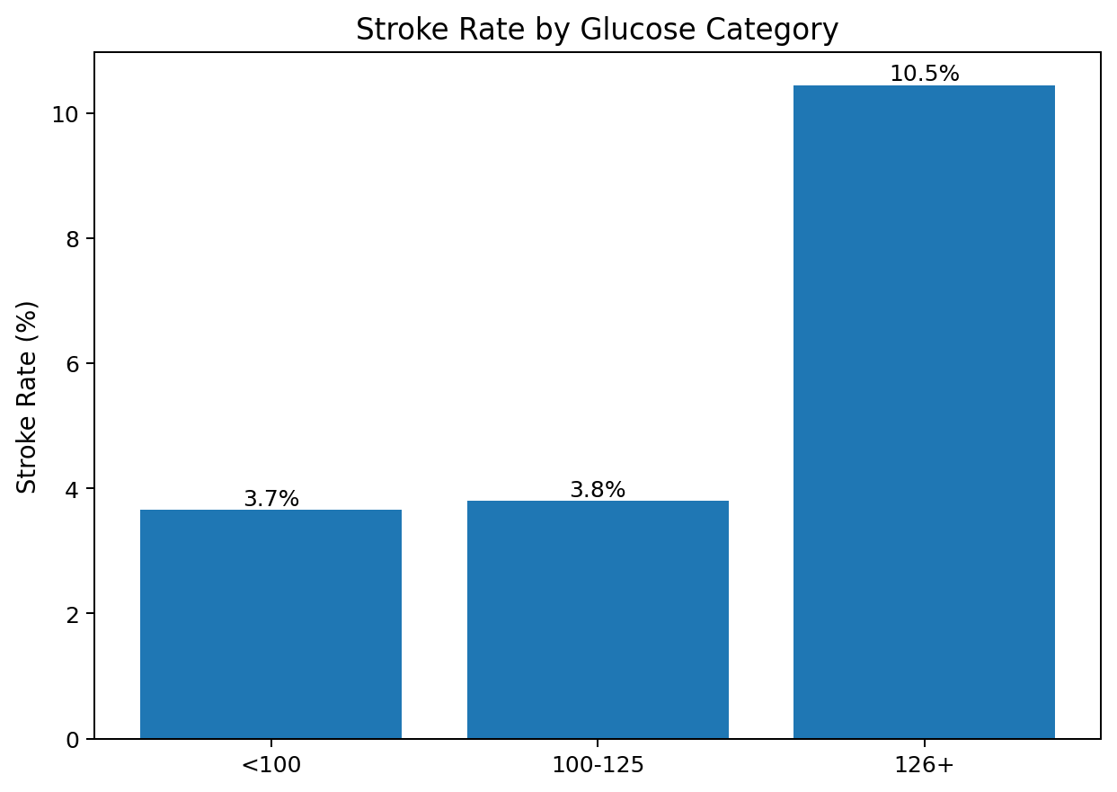
Figure 8. Stroke rate by glucose category.
Table 9. Stroke rate by work type
Work type | Patients | Stroke cases | Stroke rate (%)
Self-employed | 804 | 65 | 8.1%
Private | 2860 | 148 | 5.2%
Govt_job | 644 | 33 | 5.1%
children | 673 | 2 | 0.3%
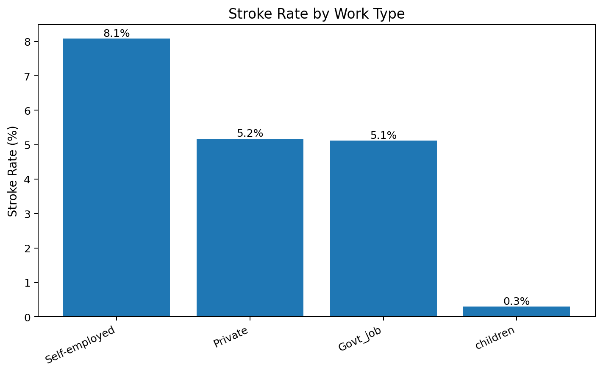
Figure 9. Stroke rate by work type.

6. Correlation Review
A correlation heatmap was produced for numerical and binary variables. Correlation is descriptive and does not establish causation. The strongest positive correlation with stroke among these fields was age, followed by weaker positive relationships with hypertension, heart disease, glucose, and BMI.
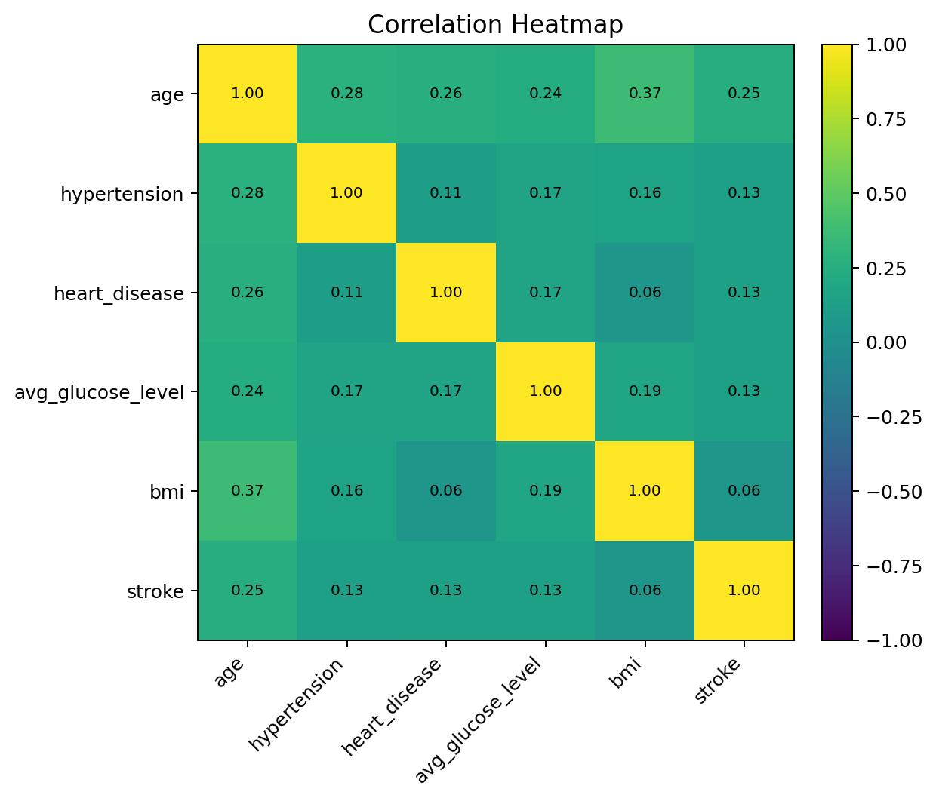
Figure 10. Correlation heatmap for numerical/binary fields.

7. Key Exploratory Findings
- Stroke prevalence was low at 4.98%, confirming that class imbalance is a central issue for later modeling.
- Stroke patients were much older on average (67.8) than non-stroke patients (42.1).
- Patients aged 66+ had the highest observed stroke rate: 16.3%.
- Stroke patients had higher average glucose (132.2) than non-stroke patients (104.6).
- Patients in the 126+ glucose category had a higher observed stroke rate than lower glucose groups.
- Hypertension and heart disease groups showed higher observed stroke rates than their corresponding non-condition groups.
- Smoking-status differences were visible, but interpretation should consider age distribution and possible confounding.

8. Interactive Dashboard
A standalone interactive HTML dashboard was created from the same visualizations. The dashboard supports hover, zoom, pan, and interactive chart review in a browser.
Item | Result
Dashboard artifact | brain_stroke_original_data_interactive_dashboard.html
Dashboard type | Standalone HTML, Plotly-based
Included views | KPI cards, stroke distribution, age/glucose/BMI boxplots, grouped stroke-rate charts, and correlation heatmap
Purpose | Stakeholder-friendly exploratory review of the original dataset

9. Interpretation Notes and Limitations
- This is exploratory analysis of observational data; it does not establish causation.
- No statistical significance testing is claimed in this EDA section.
- Stroke cases represent only about 5% of the dataset, so class imbalance must be addressed in predictive modeling.
- Some subgroup rates may be unstable where subgroup sizes or stroke-case counts are small.
- Observed differences may be confounded by age, comorbidities, and unmeasured clinical variables.

10. Files Produced
Table 10. Output files produced
File | Description
original_data_exploratory_analysis_report.docx | EDA report with embedded tables and plots
brain_stroke_original_data_interactive_dashboard.html | Standalone interactive dashboard
original_data_eda_charts.zip | ZIP file containing all PNG visualizations
numeric_summary_overall.csv | Overall numeric descriptive statistics
numeric_summary_by_stroke.csv | Numeric descriptive statistics by stroke status
*_rates.csv | Grouped stroke-rate tables

